# **TAX INVOICE** Date: 10/08/19 From: Eli’s Garden Improvements, 34a Windsor st Perth ABN: 29 312 028 484 To : Danielle Flint, 31 Wasley St, Mt Lawley, 6050 **Scope:** Usual garden maintenance Weed spray soursop around native trees in back and around playground

|  |  |  |  |
| --- | --- | --- | --- |
| **Qty** | **Description** | **Cost** |  |
| 4hrs | Labour | $200. | 00 |
| 1 | Glyphosate | $10. | 00 |
|  |  |  |  |
|  |  |  |  |
|  |  |  |  |
|  |  |  |  |
|  | **Total:** | **$210.** | **00** |

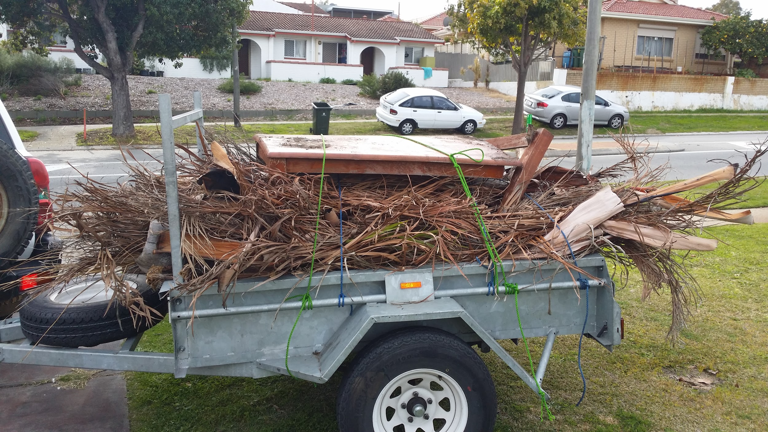

Payment Details:  
Please Pay **$210.00:**

**Eli Simic Robertson**

BSB: **086006**

ACC: **831081868**

Please pay within 7 working days.